

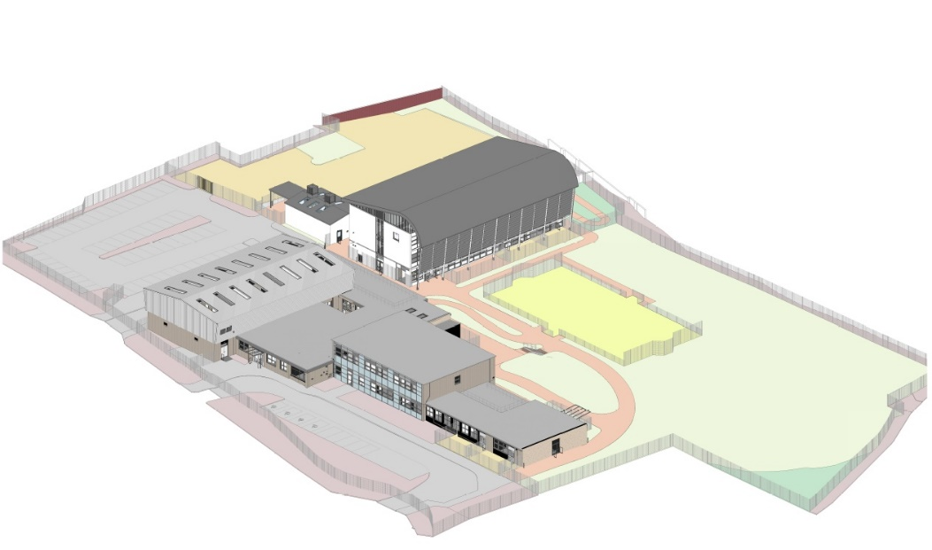



Head Teachers Welcome

Thank you for taking the time to look through our prospectus.
I am proud to introduce Soundwell Academy as a part of MNSP. We are a Social, Emotional and Mental Health (SEMH) and Speech, Language and Communication needs (SLCN) Specialist Academy.
For some pupils, mainstream education doesn't work and they might need Specialist intervention to achieve their potential. At Soundwell, we will support all pupils to achieving their potential through our core values. We will work in partnership with the pupil, families and other professionals to support academic and personal development.
We moved to our new permanent build in Soundwell in September 2021.
The staff have picked to be part of the start of something new and exciting. They all share the core values and recognise people as unique individuals with specific talents and needs. They work tirelessly to provide a varied, engaging curriculum and a positive learning experience.
If you would like to know more about our Academy, you are very welcome to come and visit.
Kind Regards
Craig Abbs
Head Teacher
Soundwell Academy

Core Values
Belonging - Our school is an environment where all members feel they belong
Kindness - We treat all members of the school community with compassion and empathy.
Honesty - We act with integrity and are self-reflective.
Resilience - We always try our best and are resilient.

Behaviour principles
We are Ready - for learning, to try our best and manage our emotions
We are Respectful - in the way we communicate, in the way we take responsibility for our choices.
We are Safe - by following instructions, by following routines and treating the school building and grounds with respect.

Academy Overview
The Academy site has 2 separate buildings. These are called Hubs. Each Hub has a specialism of supporting pupils who have Social, Emotional, Mental Health needs (SEMH) or Speech, Language and Communication needs (SLCN).
The class teacher teaches the core subjects including: English, Phonics and Reading, Maths, Science, PE, PSHE, and SMSC. Some students will visit specialist rooms around the site around the school for Art, Food Technology, and P.E.
At KS3, pupils are taught in half a primary model, and they begin to spend more time with other teachers, so that the transition to KS4 isn’t too daunting. Whereas, in KS4, pupils can choose a range of subjects to study; some on-site, and others off-site, such as Motor Vehicles, Construction, and Performing

Pupil Support
The role of the Higher Level Learning Facilitators (HLLFs) Team, first and foremost, is to provide support and nurture for our pupils around the areas of their social and emotional barriers to learning. This encompasses a wide range of support from supporting pupils on a 1-1 basis, and in small nurture groups, but also identifying areas of need from each pupil’s EHCP and from this supporting colleague with strategies to aid pupil engagement and attainment.
Should a pupil have any concerns, the HLLFs will endeavour to support them through discussion and play, and if required by consulting with colleagues from the Education team. The HLLF’s work closely with all support service agencies ranging from Social Services, YOT, Educational Psychology, and Primary Mental Health Specialist (PMHS).

