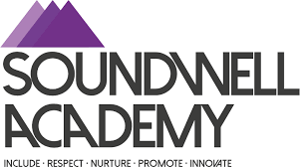
Student Ready Respectful Safe

Ready – We Will
Attend and arrive on time.
Actively listen.
Be responsible for our resources.
Learn to manage our emotions so we are ready to learn.
Try our best.

Respectful – We will
Communicate positively in every way.
Accept difference and include everyone.
Be responsible for our actions and choices.
Treat others fairly and take turns.
Recognise the value of learning.

Safe – We Will
Follow instructions.
Respect the personal space and feelings of others.
Use our Pupil Support Plan strategies to help us regulate.
Follow routines and expectations to keep our learning environment safe.
Treat the school building and grounds with respect and care.

