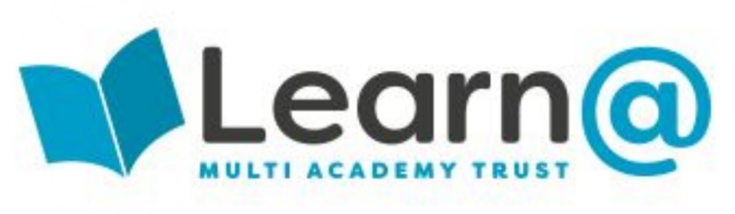



Reading



Contents
RWI 3
Reading Beyond the Read Write Inc Schemes 4
What is Reading Comprehension? 4
Simple View of Reading 5
Understanding a written text 6
Practical strategies to teach comprehension 7
Activate Prior Knowledge 8
Strategies 8
Questions to ask to prompt ‘activating prior knowledge’ conversations: 8
Learning about Words 9
Strategies 9
Questions to ask to prompt ‘learning about words’ conversations: 9
Retrieve Information from texts 10
Strategies 10
Questions to ask to prompt ‘retrieval’ conversations: 10
Make inferences 11
Strategies 11
Questions to ask to prompt ‘inference’ conversations: 11
Make predictions 12
Strategies 12
Questions to ask to prompt ‘prediction’ conversations: 12
Sequence Texts 13
Strategies 13
Questions to ask to prompt ‘sequencing’ conversations: 13
Summarise texts 14
Strategies 14
Questions to ask to prompt ‘summarising’ conversations: 14
Make comparisons 15
Strategies 15
Questions to ask to prompt ‘comparison’ conversations: 15
Evaluating texts 16
Strategies 16
Questions to ask to prompt ‘evaluation’ conversations: 16
Developing Reading Comprehension 17
The Question Matrix 17
Book Talk 18
Book Talk Grid 20
Reciprocal Reading 21
Chunking 22
Extra Questions 22
Visualise Stories and Comprehension 23
Story Maps 23
Using Visual Texts 23
Reading Detective Activities 24
Extra Resources: 25
Sign in and sign out form for books 25

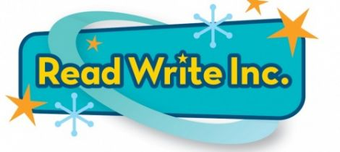

We use Read Write Inc as our scheme to teach the initial reading skills of decoding and word recognition. We use both Read Write Inc Phonics and Read Write Inc Fresh Start.
Read Write Inc Phonics is intended for use with children from Reception to Year 2 but can be used with children above this age in our setting if they feel more confident and comfortable using these books to learn how to decode.
Read Write Inc Fresh Start is intended as a catch-up scheme for children from Year 3 to Year 6 who have not yet learnt the skills of decoding and word recognition. We use this with our older learners who still need to learn decoding and word recognition but with more grown up content and book styles.
Older children can use either of the two schemes dependant on which they feel more comfortable with. Please discuss your decision with Emily, expressing why children are being put on either scheme.
Children need to be on this scheme until they are assessed and deemed ready to come off of the scheme.
Children need to be assessed at the end of each half term to ensure that we are keeping up with their progress. If children are not assessed at the end of a half term this should be for 1 of 2 reasons:
- The child has clearly not made progress in the eyes of the adults and so it is not worth the stress of assessing the child
- The child has been re-assessed recently (sooner that the end of half term) because they had made more progress that expected and needed to be assessed to suit their books to their needs.
If either of these instances occur please discuss it with the English Lead (Emily) and make them aware this is the situation.
All raw RWI assessment data needs to be passed on to the English Lead (Emily) once a child has been assessed.
Comprehension still needs to remain a focus even in these early stages of reading. It is intertwined into the Read Write Inc Scheme and becomes a regular part of your phonics sessions however these skills need to be continued to be developed outside of Phonics sessions. These need to be done at a text-based level from an early age.
Pictures have their place in the acquisition of comprehension skills however the more that children rely on predicting from pictures etc. and guessing what will happen as opposed to actually using their phonics to read and comprehend then they are more likely to delay their ability to read and understand

Reading Beyond the Read Write Inc Schemes
Once children have been assessed as being off of the Read Write Inc Phonics or Fresh Start Scheme they need to continue their work on Comprehension.
Comprehension will have been worked on throughout children’s time learning the skills of decoding and word recognition but children can now explore texts in more detail with these skills secured.
To teach a child to comprehend a text, we need to be providing opportunities to develop the following 9 core skills:
- Activate Prior Knowledge
- Learn about words
- Retrieve information from texts
- Make inferences
- Make predictions
- Sequence texts
- Summarise texts
- Make comparisons
- Evaluate texts

What is Reading Comprehension?
Reading comprehension compromises of many different skills. Comprehension is more than being able to answer surface level questions about a piece of text. Children need to understand the words that they are giving as an answer. Comprehension includes:
- Understanding the text
- Engaging with the text
- Making connections with existing knowledge
- Critically evaluating texts
- Reflecting upon responses
Prior to teaching children the skills to comprehend a text, we first need to teach them to recognise if they understand what they are reading.
Younger and poorer readers often do not recognise when they have not understood a text and they are therefore unable to make an autonomous decision to use a strategy to enhance their understanding. We need to provide the strategies for children to notice that they don’t understand.
This can be done in simple ways such as giving differentiated summary demands once children have read. Children need to explain what has happened in what they have read to prompt them to notice that they don’t or do understand what they have just read. Try asking the children the following questions:
Step 1 – When a child has read a sentence. Can you tell me who the character is in it? Or Can you tell me what the subject was? What has happened in that sentence?
Step 2 – After reading another sentence. Can you tell me who the character is and what the setting is?
Step 3 – After reading another sentence or paragraph. Can you tell me the character, the setting and some of the description of the key adults?
Step 4 – After reading a paragraph. Can you tell me all of the above and what was said?
In order to improve standards of coherence and comprehension we need to get the children to summarise, link, predict and compare to prior knowledge. Through doing this we will know what domain and general knowledge they have to work off

Simple View of Reading
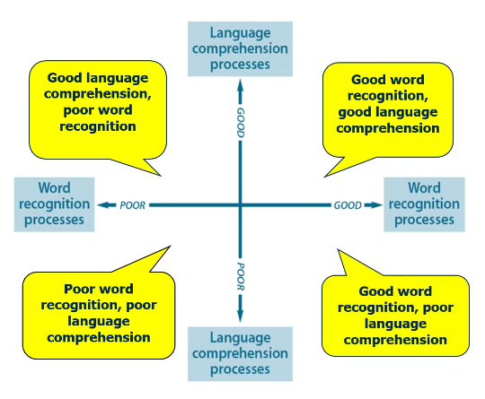

There are 2 aspects to reading:
- Decoding (Word Recognition)
- Comprehension (Language Comprehension)
4 quadrants:
- Top left: Good language comprehension, poor word recognition usually presents as really good at answering comprehension questions about films, good emotional literacy and interpersonal skills, quite sensitive, able to pick up on nuances and read the room. Struggles with books because their decoding is poor. All energy is then used up to decode text and they have no head space left to comprehend.
- Top right: Good word recognition, good language comprehension usually presents as decoding really easily and they can comprehend. These children need to be challenged to further and deepen their comprehension skills.
- Bottom left: Poor word recognition, poor language comprehension usually presents as struggle with decoding and struggle with comprehension
- Bottom right: Good word recognition, poor language comprehension usually presents as great at reading, fluent decoder but has little to no idea about what they have read. If asked the question what was the book about they would not be able to tell you.
Understanding a written text
Understanding a written text takes a variety of different skills all working together. Our aim is to equip children with these skills in order for them to understand not only written texts but the world around them.
Figure 1
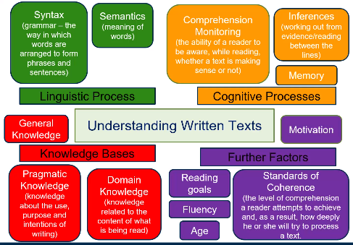
Figure 1 Understanding Written Texts (TT Education, 2021, Slide 26)

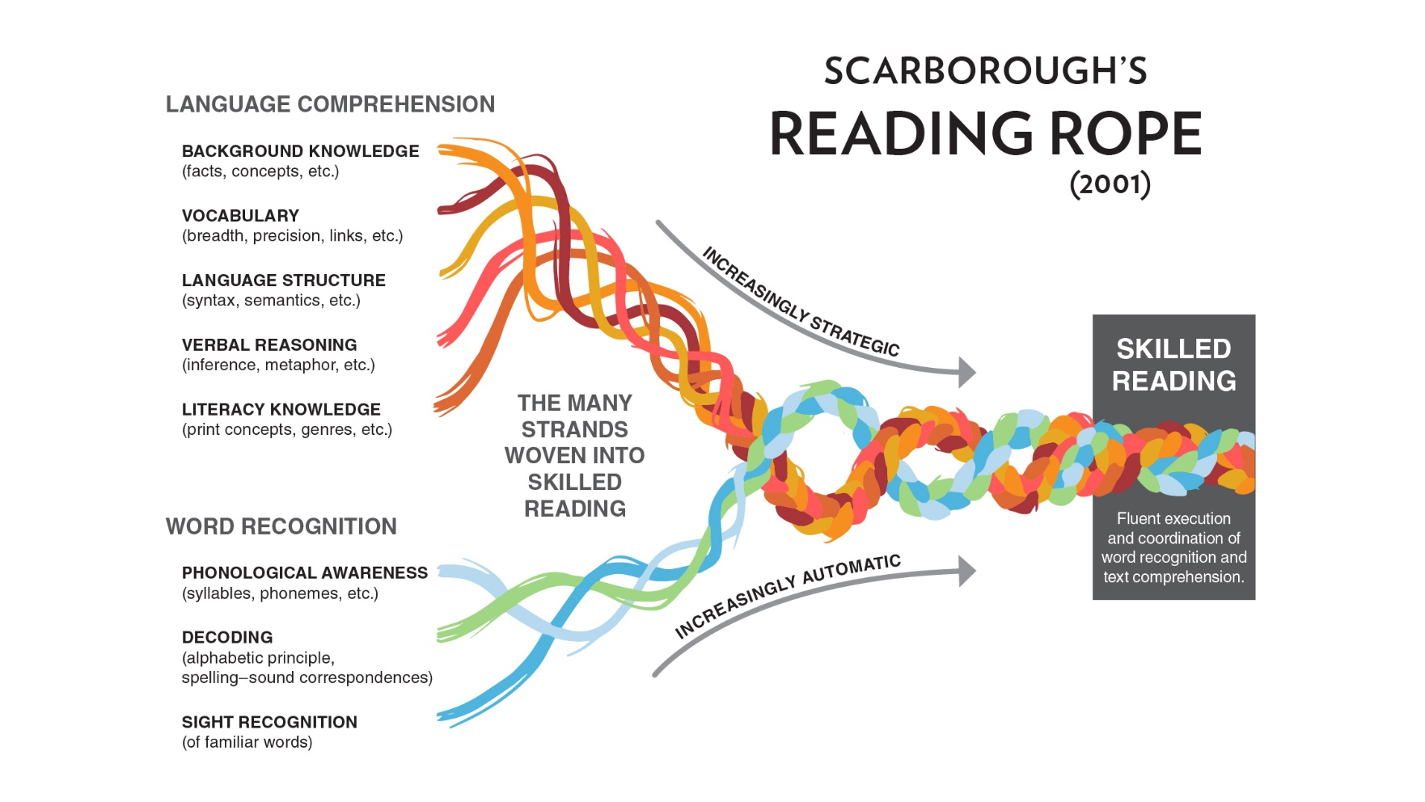

Practical strategies to teach comprehension
To teach a child to comprehend a text, we need to be providing opportunities to develop the following 9 core skills:
- Activate Prior Knowledge
- Learn about words
- Retrieve information from texts
- Make inferences
- Make predictions
- Sequence texts
- Summarise texts
- Make comparisons
- Evaluate texts
Use the following activities to create opportunities to practice these skills.

Activate Prior Knowledge
Children need to be able to see links between what they already know and the new information that they will read in different texts. Using their domain knowledge (Figure 1) they need to compare and link it to their own lives.
Children in our setting may have very little domain knowledge due to:
- the experiences or lack of experiences that they have had in their childhood
- their experiences in mainstream education
- their exposure to a variety of different texts
Children may have very little prior knowledge surrounding the topic of their book about what they are reading and this may be the reason they struggle to comprehend different texts.
We cannot pre-teach background knowledge about every text but it is possible to do it for the texts that you are going to read in your class or to cover some of the key aspects that may come up in different class books.

Strategies
- Start books by guessing what they might be about, talking about the author, the illustrator, what we predict about the book
- Book Wrap – Cover the front of a book with sticky notes. Take them off one by one with children guessing what the book could be about after each reveal.
- Don’t show the front cover at all 0 talk a book title and ask children to think about the book title. E.g. Granny Sarah and the last red/read kite. Children have the opportunity to think about all the different ways that the title could be interpreted. Is it red or read? Is it a toy kite or a bird? Is it Granny Sarah or Granny and Sarah?
Granny Sarah and the last red/read kite
Kite toy? | Granny Sarah | Red? Is it really red or a reddish colour?
Kite bird? | Granny and Sarah | Read?
The last one that she saw or the last one in existence? Is it the last one they saw/played with together? | Do Granny and Sarah know each other?

Questions to ask to prompt ‘activating prior knowledge’ conversations:
What kind of book is this?
What time period is this book set in?
What other books has this author written?
Does this book remind you of anything that has happened to you? What? Why?
If you were in a problem situation like the one in the book, how would you have acted?
Which stories have opening like this?
Can you think of another story with a similar theme?
Does this book give you any new ideas about yourself? Why?
Learning about Words
Children often need clarification of the meaning of words and phrases. Common words which we may think children have heard before and understand often are not understood and need to be talked through in the context of the text being read. (This will be a focus in our vocabulary lessons but needs to be worked on throughout all literacy and reading lessons.)
Learning about words is a time to think about not only the meaning of words but the effect and impact they have on a sentence and the overall piece of text.
Strategies
Silly Sentences
- Pick a small passage of text and ….. different words from the passage to different groups/individuals.
- That child or group of children need to think of as many synonyms for that word as possible.
- Ask children to sort words into different continuums e.g. most letters to fewest letters, scariest sounding to least scary, words that are more common to less common etc.
- Each table or individual then chooses their favourite word from their synonyms
- Everyone comes back together and the teacher reads through the text passage leaving out the words that were given out to the groups or children. The groups/children shout out their chosen word in place of the original word.
- Look at how the effectiveness of the text has changed with the new words. What are the new words like in comparison with the original ones? Has it affected the rhythm of the story? The cohesion? The flow? Formality? Technicality?
This activity can be done with children of any age. Only pick a small passage of text when doing this activity to ensure that you can analyse the effectiveness of the new words accurately when reading back through together.

Questions to ask to prompt ‘learning about words’ conversations:
Can you find one word that describes a character in your book very well?
List 5 new words you learned in the book. Write down their dictionary pronunciation and meaning.
List 10 good words from your book. Why are they good words? Put them into a word search.
Are there any words that you do not know the meaning of? Can you look them up?
Can you work out the meaning of ……. Looking at contextual clues and using your prior knowledge?

Retrieve Information from texts
In order to retrieve information from a text, children need to be taught strategies to help them in knowing where in the text they need to look and what to look for.
Literal level questioning can be used here where the answer can be found directly in the text and they need to locate the information, however, it is important to remember that we want children to be able to retrieve more than just basic level information. A child can tell you the keyword answer you are looking for but they may have no idea what that keyword means.
We need to teach children not only to comprehend texts but to comprehend the questions that they are being asked.

Strategies
- Try and rephrase questions to get children to retrieve the same information but in a ………. Way.
E.g. Using the follow small passage of text, instead of asking ‘What did Charlie find?’ ask ‘What was the purpose of Charlie’s search?’
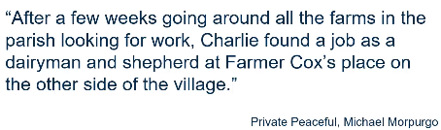

Constructing Images
Children listen to someone reading (teacher or student) and have to draw or write something while you are reading a description.
- Draw a character based on information gathered from the text
- Draw a map of a quest or journey based on details from the story
- Draw a diagram to represent an instruction or explanation text
Questions to ask to prompt ‘retrieval’ conversations:
Can you list the places in the book that are important?
How would you prove…?
Can you identify one problem in the book?
Where and when did the story take place?
Who are the main characters? Describe what they are like?
What does the main character look like?
Where in the book would you find…?
Can you make a list of facts you have learnt from this book?
How does the book begin?
What is the time period in which the book happens?
Where did the story take place?
What problems does one of the characters have, and how does he or she solve it?
If your book was a mystery, tell me what the mystery was and how they solved it.
Did anyone in the book do something you did not like? Why?
Make inferences
Inference is often seen as the top of the hierarchy of comprehension skills and is often paired with deduction. Inference is the skill of hypothesising and deduction is the conclusion that you draw from it.
Children need to be taught how to use their prior knowledge and experiences along with the clues in the text to make accurate inferences.
This can be harder when children are younger due to the nature of children’s books. Picture books and younger reader books often use shorter sentences with many full stops resulting in lots of children not associating each sentence with the next. This skill needs to be introduced and taught and can be done so by using more conjunctions in writing.
Follow these 4 steps to teach inference:
- We need to find clues to get some answers
- We need to add those clues to what we already know or have read
- There can be more than one correct answer
- We need to be able to support inferences
Strategies
Using the following guide can help children to structure their ideas and thinking:
I think that what could happen next is (Write down your prediction) I say this because I know that (Write here what you already knew before reading the book). The book also says that (write here an idea you read from the book). Also I inferred that (Write here something you figured out from the book) because (Write here what clues helped you figure that out).
This website provides pictures and questions to use to develop inference skills:
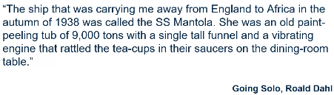
https://www.onceuponapicture.co.uk/the-collections/the-inference-collection/

For a text like the one above, a question like ‘What is the author’s impression of the ship?’ seems like an inference question however prompts a retrieval answer with a child answering ‘it was a paint peeling tub with a tall funnel and a vibrating engine’.
Inference needs to be deeper. The answer may not be any words in the text but it may be backed up with words from the text e.g. ‘It was a negative impression because the paint was peeling off etc.’.
Questions to ask to prompt ‘inference’ conversations:
Are there any other reasons this may have happened?
What would this character think if?
Using the evidence in the text, what do you think about?
Can you explain why…?
If you were the main character, how would you have reacted to…?
How did the main character feel during the book? How do you know?
What is happening? What might this mean?

Make predictions
To explain your prediction think about:
- What did you know before reading the book?
- What is mentioned in the book or what can you infer (work out) from the story?
All around the question ‘What do you think might happen next?’ Predictions needs to be based on contextual clues.
Strategies
Predictometer
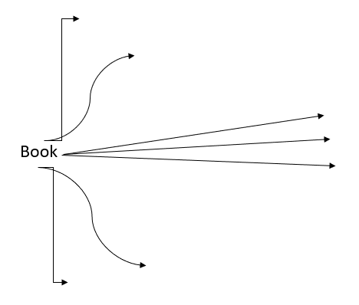

The predictometer can be used to answer the question ‘What do you think might happen next?’
Use the curves lines or vertical lines to record any predictions that are not realistic to the story. These predictions will not follow the clues in the text that you have already read. Use the straight lines to predict things that you think are realistic to the story (using contextual clues).
It is good for children to see some unrealistic predictions so that they can talk about why they are unrealistic.

Questions to ask to prompt ‘prediction’ conversations:
What would the main character be likely to do if she/he visited our classroom?
Can you make up a map of the important places in the book as you imagine they may look?
What could the main character be doing 10 years after the story is set?
What would think character think if?
What changes would have to be made if the book occurred 200 years ago?
Could you pretend you are one of the characters in the book and write a diary about your life for two consecutive days?
If you were the main character, how would you have reacted to…?
What would happen if…?
If you could continue the story, what events would you include? Why?
Name 1 main character. Rewrite the story from their point of view.

Sequence Texts
Sequencing can be done through text, films, photos or any other form of story telling media. The core skill here is to internalise the story through recall.
Strategies
Poems: match rhyming words at the end of lines; put lines of the same length together to form verses; think about meaning and make sure it makes sense; identify lines that could start/end the poem.
Stories: use knowledge of the 5 stages of a story to identify the opening, build-up, problem, resolution and ending; look for sentence starters e.g. Meanwhile…, Finally; check that it all makes sense etc.
Non-fiction: e.g. instructions; look for the key features such as the list of what is needed; look for logical order; use conjunctions e.g. First, Next…
Questions to ask to prompt ‘sequencing’ conversations:
Can you organise this book into 3 or more sections and give your own subtitle for each?
Can you list the five major events in the story in the correct order?
Make an 8 section comic strip with captions showing the main events of the story

Summarise texts
Children need to learn how to identify the main idea in a text. This can be done by going through a text paragraph by paragraph, identifying the key sentence in each. Children need to be taught how to restructure key information from a text e.g. take notes or label a picture.
Strategies
Using a printed-out page or paragraph with sticky notes to write on.
Use this 3 stage model:
- Step 1 – Can you find a key clause? – Word for Word copy out the sentence that you/the child feels summarises the paragraph/page that you are focusing on
- Step 2 – Write 4-5 words that give the idea about what is going on in that page. They can now use some of their own words but may still mainly use the words from the page/paragraph. At this point the children’s writing may start to lose the grammar (this is fine). The 4-5 words that they choose could just be 5 words from throughout the paragraph with commas in between.
- Step 3 – Now cross out the 4-5 words and find 1 word that gives you the summary of that paragraph/page/5words. This word is likely to be an abstract word or noun.
This is not an activity to be done with every page/paragraph but can be done for key moments throughout the book.
Children get a chance to practice both content summarisation and function summarisation in these steps (Step 1 = Content, Step 3 = Function). Step 3 often helps towards writing sub headings.
This is a great activity to reinforce note taking and knowing how to extract key bits of information.

Questions to ask to prompt ‘summarising’ conversations:
Can you write a letter to a friend recommending this book?
What lesson did you learn from the story?
Can you write a radio announcement to advertise this book?
Which text is more persuasive? ……. Or ………? Why?
What is the book about?
What kind of book is this? Can you list 3 reasons why you know this?
What did the title have to do with the book?
Decide which parts of the book include the five W’s (who, what, when, where, why) and the H (how). Write a paragraph for a newspaper article including these facts
Find 1 word that describes a character in your book very well. Give 5 reasons for your choice of word.
In a paragraph, state the main idea of the book as if you are recommending it to them
Design a poster for this book
Design a book jacket that illustrates the kind of book as well as the story
Design costumes for the characters

Make comparisons
Children need to be taught to make comparisons within and across books looking at:
- Settings
- Characters
- Events
- Themes
Strategies
Perfect Partners
- Children have small cards under their chairs (or given to them) and have to find their ‘perfect partner’. The cards will have different literary duos on them and children need to find the other half of their duo. This part of the game relies on children’s prior knowledge of literary characters that are associated with each other so try and use characters from books you have already read in your class.
- Children then sit with their ‘perfect partner’ and draw the setting for the characters that they are.
- Children then go around the room looking at each others drawings and write adjectives on each others pictures to describe the setting.
- After this they can go back to their ‘perfect partner’ and start to write a descriptive paragraph about their setting with their partner. This can progress onto the children rewriting the story for their characters if this is appropriate for your class.
Character Sort
- Using either: lots of characters from the same story or lots of characters with similarities from different stories children are asked to order the characters in different ways. E.g. If ordering the characters from Louis Sachar’s Holes, you might get the children to order the characters by height, from meanest to kindest, from bravest to most scared etc.
- If you were using lots of characters from different books you might ask children to sort them into ‘baddies’ and ‘goodies’, who fills the same role e.g. the witch, the hero etc.
- Children can be given the chance to choose their own criteria to sort their characters into. Once sorted, children can circulate around the room to look at others people’s tables and guess how they have ordered their characters. Children must answer the question ‘What is the criteria they have chosen?’

Questions to ask to prompt ‘comparison’ conversations:
If your story happened in a foreign land, can you compare it to where we live?
If your story happened long ago can you compare that time with today? Tell me how it would be different.
Can you compare this book to the last book you read?
If you were in a problem situation like one in the book, how would you have acted?
Have you had any similar experiences?
Can you think of another story with a similar theme?
Can you think of another author who writes in a similar style?
Can you think of another story character similar to a character in this book?
Can you write a different ending to the book? Is yours better? Why?
Which text/story is better? Why?
Evaluating texts
Children need to be able to make a judgement about or formulate a response to a text.
We need to explicitly teach children how to:
- Use effective language when evaluating texts
- Explain their opinion and justify them
- Listen to the opinions of others
Children often to not have a bank of evaluative sentences to use when they are evaluating a text so they first need to be taught evaluative language in order to do this.
Strategies
Evaluative Sentences
- The structure was unclear
- The illustrations were better than the text
- I would have liked more illustrations
- This is not appropriate for (age)
- It’s a bit gruesome/disgusting/rude/unpleasant
- It took too long to get to the interesting part
- I identified with the main character/the author’s enthusiasm
- The author seemed to be showing off a bit
- I think I needed to read the prequel
- Id like to read the sequel
- I would have liked more information
- The baddie deserved their ending
Have these sentences on little cards. After reading get the cards out and organise them into 3 piles of: I agree with this, I don’t agree with this and this is not relevant. This should be done in a group to encourage children to talk about what they are thinking.
Use the same cards every time you do this activity so that children get used to the phrasing and eventually start using these phrases automatically. You wont be able to use them all for fiction/non-fiction.
Children will eventually be able to create some of their own cards to add into the pile.
Questions to ask to prompt ‘evaluation’ conversations:
How has the author used description to show how the character is feeling?
How does the layout help?
What evidence can you use to support your view?
Why did the author choose those words?
What motive did the main character have to behaving in the way they did?
Can you think of another author who writes in a similar style?
What is the relationship between the main characters?
Do you like the way the story ended? Why?
Which character in the book would you choose for a friend? Why?
If you could only save one character from the book in the event of a disaster, which one would it be and why?
Who do you think the author intended to read this book and why?
What did you think was the most interesting part of the book? Why?
Have the views in this text affected your opinion? Why? How?
What parts of the text could be improved? What part would you change in the story? Why?
Do you agree with the actions of the main character?
Did the book have an effective ending? Who would you recommend this book to?
What was the author’s purpose or purposes in writing this book?
Identify 1 problem in the book and give an alternate solution not given by the author.

Developing Reading Comprehension

The Question Matrix
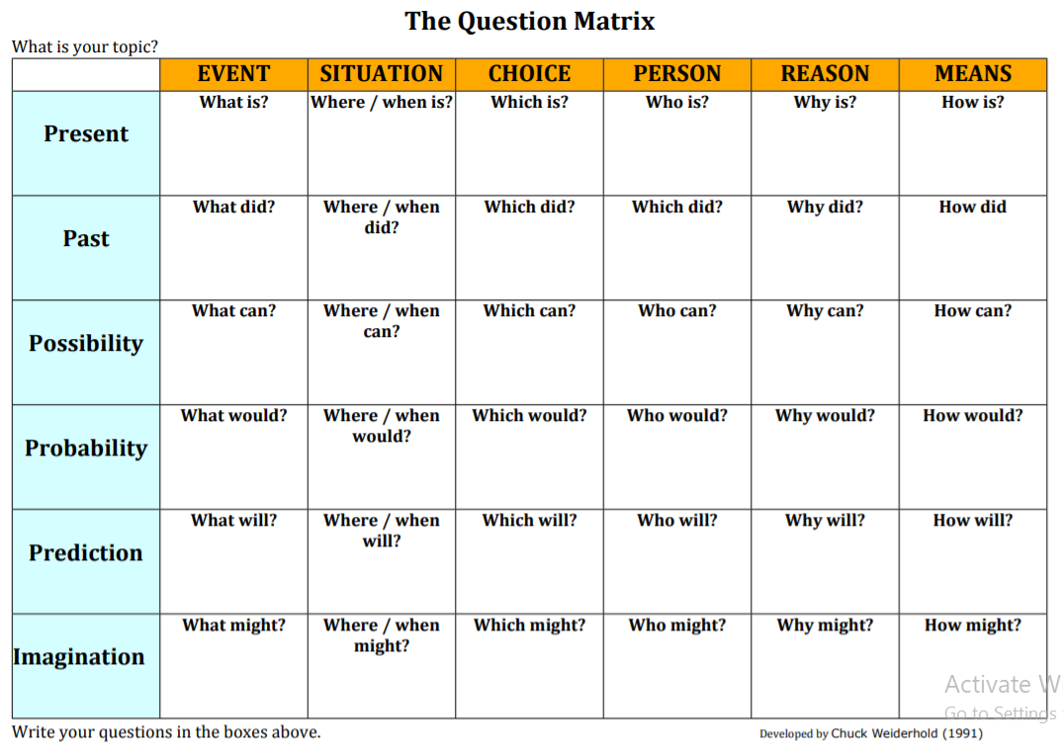
Literal (retrieval) questioning: where the answer can be found directly in the text and you need to locate the information (Top Left)
Inferential (deductive) questioning: where the answers are indirectly stated, implied or require other information (Middle)
Evaluative (and comparative) questioning: where the reader needs to make a judgement or formulate a response based on their previous reading/life experiences and their opinions on issues relevant to the text (Bottom Right)
Use the question matrix alongside LICE questions – Literal, Inferential, Comparative and Evaluative.

Book Talk
Book talk offers a different way of exploring a text which allows the pupils to take control of the discussion rather than it being teacher led. However, book talk only works if the books that you are reading have anything worth saying about them.
Go through a text and talk about what is happening in your head as you read to make children aware of the thinking process behind reading. Don’t do with a large piece of text as it takes a while to do.
Prompts to use:
- I’m not sure but…
- I was wondering whether…
- Perhaps…
- It reminds me of…
- It makes me feel…
- I wonder if…
Only use the prompts when children have done enough book talking and understand how to structure the thoughts in their head. Children can use the prompts to think of something to say about the passage.
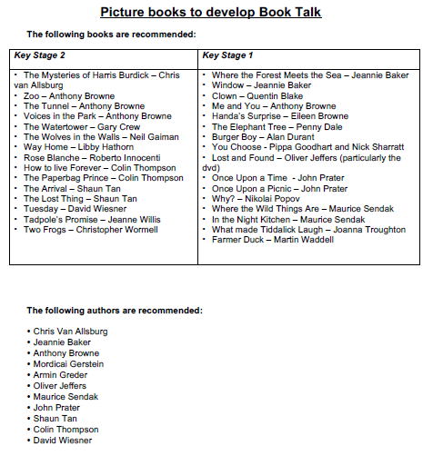

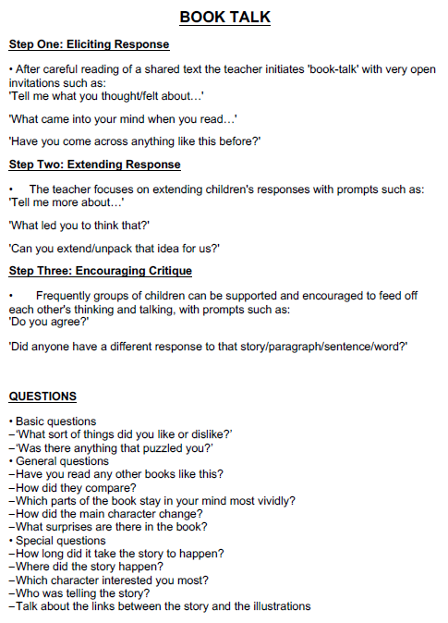
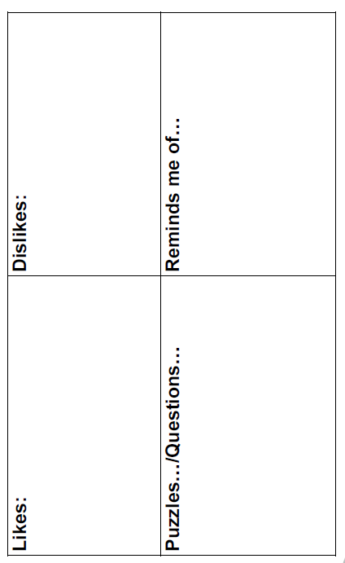
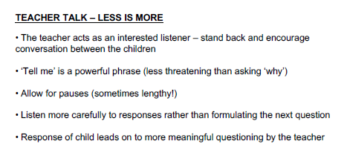

Book Talk Grid

Reciprocal Reading
This is a process which trains the children to monitor their own understanding of texts. After initial modelling of the process by the teacher, the children work independently in groups, taking it in turns to be the group leader.
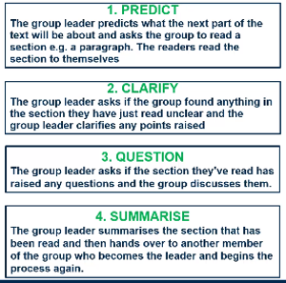

Using this process, children can lead the discussion themselves rather than the adult doing it. Children receive clear roles in their groups. These roles can change day to day and can even change roles from page to page so that everyone gets a chance to be the leader for each section of the reading.
Roles:
The Predictor – predicts what is going to happen on the next page
Clarifier – asks the top left questions in The Question Matrix (literal level questions)
Questioner – asks more open ended, evaluative, comparative and inferential questions in The Question Matrix (middle to bottom right questions)
Summariser – summarises what has just happened on the page.
After children have done all parts of the process for a page/paragraph/chapter, children can move badges round and start new roles for the next bit of text or children can keep the same badges and the predictor starts again for the next chunk of text.

Chunking
An opportunity to go through and identify features but look at the reason for that and the effect that it has. Looking into writing, children can look back at the effect column and try and use the things that they identified to put specific effects in their writing.
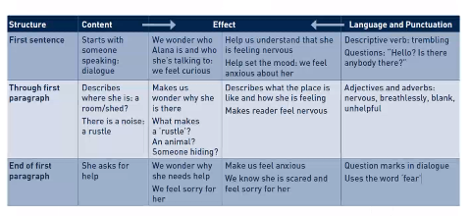

Structure Cross referencing column – Line 6 etc
Content Sentence level and above
Effect the effect that the content has on the story/reader. Answer the question ‘What does that do to you as a reader?’
Language and Punctuation Less than sentence level – grammar, punctuation and spelling, language features, word choice
Extra Questions
Inference
Describe what is happening in the first illustration of the book.
What would the main character of the book be likely to do if they visited our classroom?
Tell me 5 ways the main character is or isn’t like you
From whose point of view is the story told?
Comparison
Compare this book with the last book you read
Compare 2 of the characters in this book
Evaluative
Write another short story using the same characters
Choose an interesting character from your book. Think of what their likes and dislikes are then think of a gift that you would like to give them. Design a greeting card to go along with the gift in which you explain why you gave them that gift.
Tell in your own words how the setting of the story made it more interesting

Visualise Stories and Comprehension

Story Maps
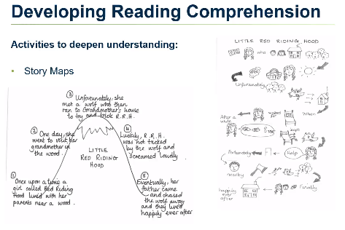
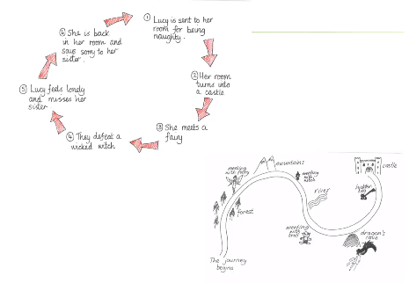

Using Visual Texts
Using visual text can be very effective when teaching
comprehension. Some useful resources are:
- www.takeonepicture.org (paintings)
- www.carnegiegreenaway.org.uk (picture books)
- www.filmeducation.org/resources/primary/ (film clips)
- www.pobble365.com
- www.OnceUponAPicture.co.uk
- www.literacyshed.com

Reading Detective Activities
These are quick fire reading games that can provide daily practice in order to improve reading skills. The key is to complete them on a regular basis using short passages of text. The skills that are developed can then be applied to longer texts.
Spot the key points
30 seconds to read through a small piece of text and tell me 3 facts from the text.
Be a detective
Tell me something about the character from the text. 30 seconds – 1 minute
Infer the characters feelings
Read through a small passage of text and talk about what the character is feeling and how we know that from the text
Predict the Consequences
What happens next?
Word Meanings
Find a text with some made up words in and talk about what they could mean. Use contextual clues to discuss what would be most appropriate for it to mean
In one word
Summarise the text in one word
Concept Cartoons
Look at different concept cartoons and discuss the opinions of the characters. Think about different viewpoints and the evidence that children have to back up their opinion.

Extra Resources:
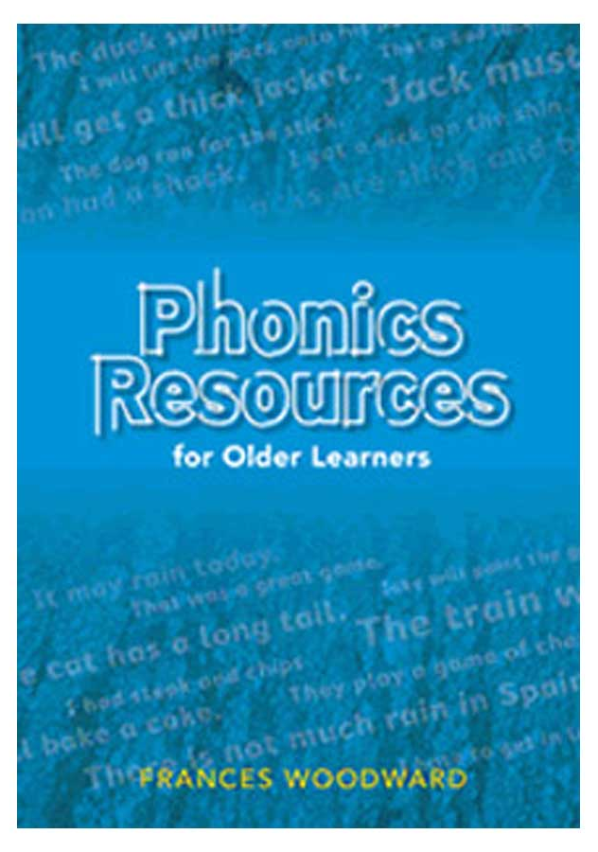
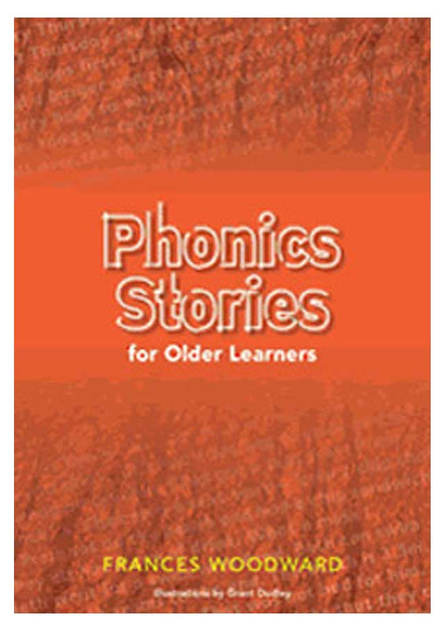

These books have a variety of small text chunks and activities in them that can be used in lesson time or during reading comprehension time.

Sign in and sign out form for books
This form will be in the English resource cupboard and will need to be completed every time you take a resource from the cupboard.
Book Title | Amount | Class | Date Checked Out | Signature | Date Checked In | Signature

